Name | Manish Shashikant Jadhav
UID no. | 2023301005

Experiment 3
AIM : | Write a program which creates exactly 16 copies of itself by calling fork () only twice within a loop. The program should also print a tree of the pids.
Discussion & Output: | Fork.c  #include <stdio.h>  #include <sys/wait.h>  #include<unistd.h>  void printTree(int pid,int level){  for(int i=0;i<level;i++){  printf("\t");  }  printf("PID:%d\n",pid);  }  int main()  {  int process=16;  int level=0;  pid_t parentpid=getpid();  for(int i=0;i<process;i++){  pid_t childpid=fork();  if(childpid==0){  level++;  printTree(getpid(),level);  }  else if(childpid>0){  wait(NULL);  break;  }  else{  printf("Fork failed.\n");  return 1;  }  }  if(getpid()==parentpid){  for(int i=0;i<process;i++){  wait(NULL);  }  printf("All processses created.\n");  }  return 0;  }  Output:  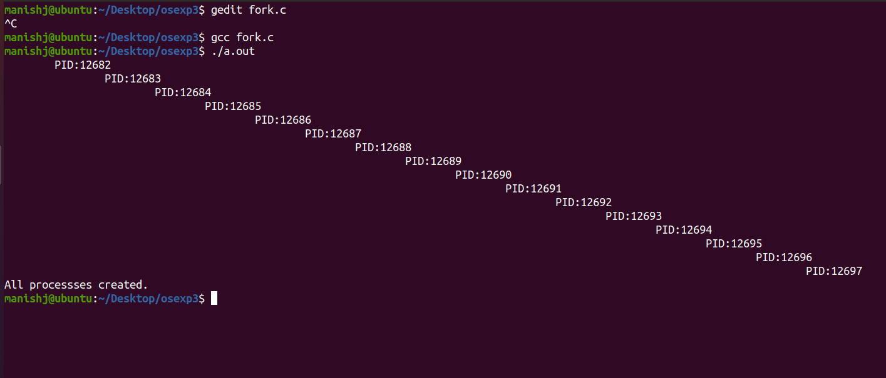  2) Demonstrate the following system calls with examples.  Fork() System call, Wait() system call, Orphan Process, Zombie process.  - fork():  #include <stdio.h>  #include <unistd.h>  int main() {  pid_t pid = fork();  if (pid == 0) {  // Child process  printf("Child process: PID = %d\n", getpid());  } else if (pid > 0) {  // Parent process  printf("Parent process: PID = %d, Child PID = %d\n", getpid(), pid);  } else {  // Fork failed  printf("Fork failed.\n");  return 1;  }  return 0;  }  Output:  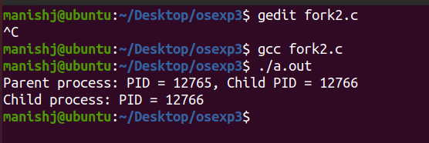  - wait():  #include <stdio.h>  #include <stdlib.h>  #include <sys/types.h>  #include <sys/wait.h>  #include <unistd.h>  int main() {  pid_t childPid;  // Create a child process  childPid = fork();  if (childPid == -1) {  perror("fork");  exit(EXIT_FAILURE);  }  if (childPid == 0) {  // Child process  printf("Child process (PID: %d) is running.\n", getpid());  sleep(3); // Simulate some work in the child process  printf("Child process (PID: %d) is exiting.\n", getpid());  exit(EXIT_SUCCESS);  } else {  // Parent process  printf("Parent process (PID: %d) is waiting for the child to exit.\n", getpid());  int status;  pid_t terminatedChildPid = wait(&status);  if (terminatedChildPid == -1) {  perror("wait");  exit(EXIT_FAILURE);  }  if (WIFEXITED(status)) {  printf("Child process (PID: %d) exited with status %d.\n", terminatedChildPid, WEXITSTATUS(status));  } else if (WIFSIGNALED(status)) {  printf("Child process (PID: %d) terminated by signal %d.\n", terminatedChildPid, WTERMSIG(status));  }  printf("Parent process (PID: %d) is done.\n", getpid());  }  return 0;  }  Output:  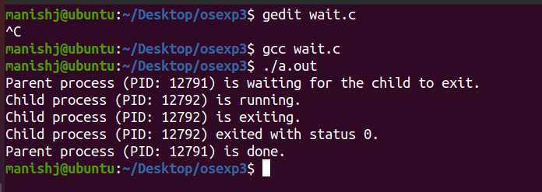  - orphan():  #include <stdio.h>  #include <unistd.h>  int main() {  pid_t pid = fork();  if (pid == 0) {  // Child process  sleep(5);  printf("Orphan Child process: PID = %d, Parent PID = %d\n", getpid(), getppid());  } else if (pid > 0) {  // Parent process  printf("Parent process: PID = %d\n", getpid());  } else {  // Fork failed  printf("Fork failed.\n");  return 1;  }  return 0;  }  Output:  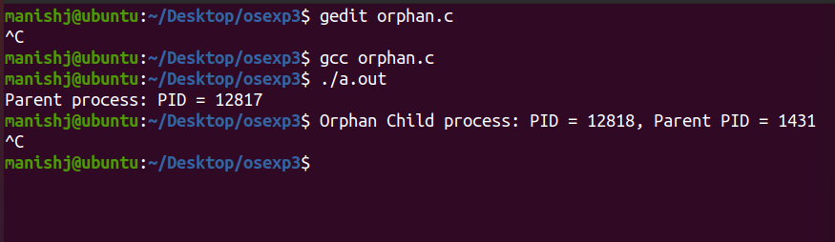  - zombie():  #include <stdio.h>  #include <stdlib.h>  #include <unistd.h>  int main() {  pid_t pid = fork();  if (pid < 0) {  // Fork failed  fprintf(stderr, "Fork failed.\n");  return 1;  } else if (pid == 0) {  // Child process  printf("zombie Slept.\n");  exit(0); // Child process exits immediately  } else {  // Parent process  sleep(10); // Parent process sleeps for 5 seconds  printf("Zombie Wakesup after 10 seconds\n");  }  return 0;  }  Output:  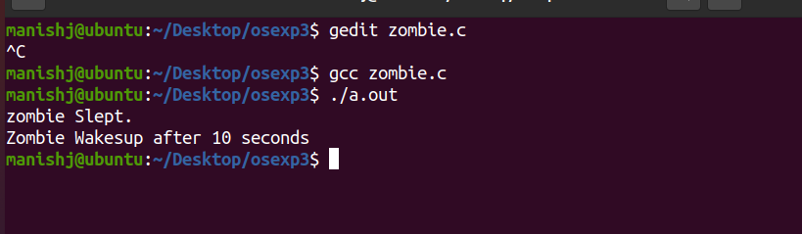
CONCLUSION: | Hence, by completing this experiment I came to know about how to write a program which creates exactly 16 copies of itself by calling fork () only twice within a loop. The program should also print a tree of the pids and also to demonstrate wait() system call, orphan(), and zombie() function.

